PROJECT NAME :News Tracker Application TEAM ID :PNT2022TMID43620

IMPLEMENTING WEB APPLICATION

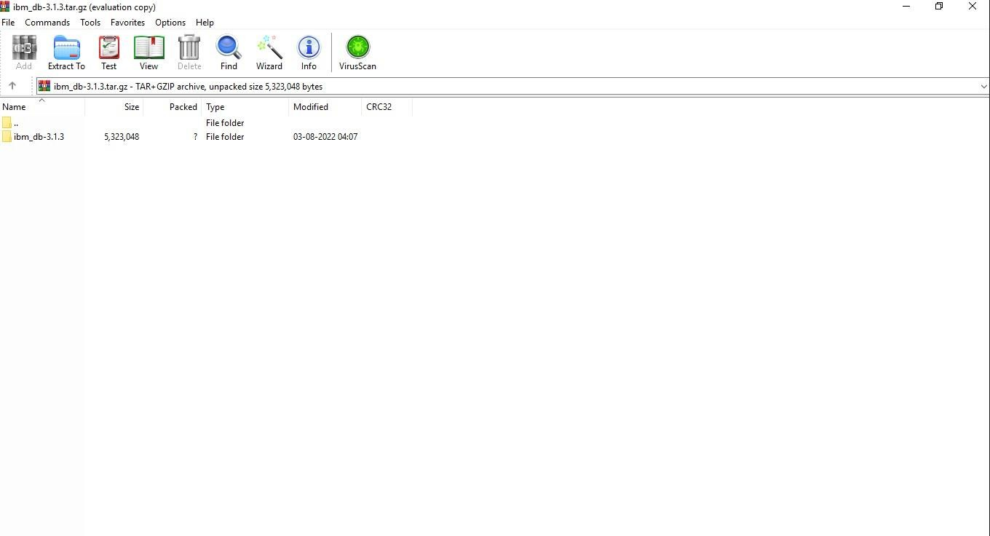

Create IBM DB2 and connect with python